A

**Project Report On**

**Gym Management System**

**Submitted by**

**Amisha Gupta [2205112110002] Vishal Kumar Mahto [2205112110114]**

**as**

**Partial fulfilment of Semester 4 of Master of Computer Applications**

**for A.Y. 2022-2023**

**Under the Guidance of**

**Prof. Faruk Abdulla**

**Submitted To Department of MCA**

**Faculty of IT & Computer Science Parul University**





**CERTIFICATE**

This is to certify that **Ms. Amisha Gupta, Enrollment No. 2205112110002, Mr. Vishal Kumar Mahto, Enrollment No. 2205112110114** student of Master of Computer Applications has satisfactorily completed the Major Project on **“Gym Website”** at **Company Name** as fulfillment of MCA Semester IV.

Seat No. Date of Submission:

Internal Guide Project Coordinator Director - MCA

**Department of MCA Faculty of IT & Computer Science**

**PARUL University, Vadodara**

**1. INDEX**

|  |  |  |
| --- | --- | --- |
| **No.** | **Description** | **Page No.** |
| **1.** | **About Department of MCA** |  |
| **2.** | **Company Profile** |  |
| **3.** | **Project Profile**   * 1. Gym   2. Gym Description   3. Existing System / Work Environment   4. Problem Statements   5. Need for New System   6. Proposed System & Features   7. Scope   8. Outcomes   9. Tools & Technology used   10. Project Plan |  |
| **4.** | **Requirement Analysis**   * 1. Feasibility Study   2. Users of the System   3. Modules   4. Process Model   5. Hardware & Software Requirements   6. Use Cases   7. Use Case Diagram |  |
| **5.** | **Design**   * 1. Use Case Scenarios   2. Diagrams      1. UML / DFD      2. Entity Relationship Diagram   3. Data Dictionary |  |
| **6.** | **Implementation**   * 1. Form Layouts   2. Report Layouts   3. Coding Convention |  |
| **7.** | **Testing**   * 1. Test Strategy   2. Test Cases |  |
| **8.** | **Future Enhancement** |  |
| **9.** | **Bibliography** |  |

1

# About Department of MCA

**PARUL University**

Parul University is a legitimate university established under Gujarat Private University Act 2009, after legislation passed by the Government of Gujarat on 26th March 2015 giving University status to Parul Group of Institutes functioning under the aegis of Parul Arogya Seva Mandal Trust.

# Faculty of IT & Computer Science

Faculty of IT and Computer Science, Parul University has materialized as one of the prime IT education providers at global level. Various departments under Faculty of IT and Computer Science strive in preparing IT-industry ready professionals by means of various skill development courses, vocational courses, co-curricular & extra- curricular activities, industry visits and expert lectures.

# MCA Department

The Department of Master of Computer Application at Parul University emphasizes on building professionals in the domain of computer applications by providing necessary environment by means of facilitating suitable blend of technical and non-technical learning experience. The department cultivates students in various curricular, co- curricular and extra-curricular activities in order to produce future system analysts, system designers, system programmers, application programmers, testing professionals, system managers, project managers, researchers and other leading positions in systems/IT department.

The department offers various subjects from diversified technical/non-technical areas such as – core IT domain, management, communication skills, mathematics & logic building and rich pool of elective subjects.

The department of MCA focuses on project-based learning, and hence students are motivated to work on tiny hands-on projects in practical oriented subjects to get better exposure. Moreover, throughout their MCA studies, students are required to work on around 3 mini/major projects in individual/team to get enough confidence on software-development and thereby become industry-ready.

Gym Management System

# 2 Project Profile

### Project Definition

The Gym Management System is a comprehensive software solution designed to streamline and automate the operations of a fitness center or gym. It encompasses various functionalities, including member management, class scheduling, attendance tracking, billing, reporting, and more.

This system aims to provide an efficient and user-friendly platform for both gym members and staff to manage their activities seamlessly. It covers aspects from membership registration to class attendance tracking and financial management. The name Agriculture Management System indicates intelligent Agriculture.

An Agriculture Farm Management System aims to empower farmer with modern technology and data driven insights to optimize their operations, increase yields, and contribute to sustainable and profitable agriculture practices.

### Project Description

In the fast-paced rhythm of contemporary life, where stress and sedentary habits dominate, the gym emerges as a haven for those seeking balance and vitality. More than just a facility adorned with exercise equipment, the gym represents a holistic approach to health, offering benefits that extend far beyond physical fitness.

Walking into a gym is stepping into a realm where determination and dedication collide. The atmosphere is charged with the collective energy of individuals committed to bettering themselves. The rhythmic beats of music provide the backdrop to a symphony of weights clanging and machines humming, creating an ambiance that motivates and inspires.

One of the primary virtues of the gym is its versatility. It caters to people of all fitness levels and backgrounds. Whether you're an elite athlete aiming to push boundaries or a beginner embarking on a wellness journey, the gym accommodates and encourages all. The array of equipment allows for targeted workouts, focusing on specific muscle groups or overall cardiovascular health.

A distinctive feature of the gym is the presence of trained professionals who serve as guides on the path to fitness. Certified trainers offer expertise, crafting personalized workout regimens and providing valuable insights into nutrition. Their role extends beyond physical training; they become mentors, offering encouragement and fostering a sense of accountability that transcends the gym floor.

However, the gym is not merely about lifting weights or running on a treadmill; it is a hub for holistic well-being. Group fitness classes, ranging from high-intensity sessions to yoga and meditation, cater to diverse interests and preferences. This diversity ensures that individuals can find activities that resonate with them, making their fitness journey not only effective but enjoyable.

Beyond the physical transformations, the gym acts as a social nexus. It is a place where like-minded individuals converge, forming a supportive community. Friendships are forged amidst shared challenges and triumphs, creating a network that strengthens the resolve to maintain a healthy lifestyle. The camaraderie in the gym goes beyond the surface, fostering mental resilience and emotional well-being.

In essence, the gym is more than a space for exercise; it is a sanctuary for self-improvement. It symbolizes a commitment to a healthier and more balanced life. As individuals lift weights and engage in cardio, they are also lifting their spirits and enhancing their mental resilience. The gym becomes a space for self-discovery, where limits are tested, and barriers are broken.

In conclusion, the gym is a multifaceted institution that goes beyond the realms of physical fitness. It is a holistic sanctuary where individuals sculpt their bodies, train their minds, and cultivate a sense of community. As society grapples with the challenges of modern living, the gym remains a steadfast ally, offering not just a place to work out, but a refuge for those seeking a path to well-being. In essence, the Agriculture Farm Management System brings digital transformation to agriculture, equipping farmers with the tools and insights they need to operate more efficiently, sustainably, and profitably in an ever-evolving industry.

# Existing System / Work Environment

### Traditional Paper-Based Registration and Tracking:

In many gyms, the registration process and member tracking are still conducted using traditional paper-based systems. This involves manually filling out registration forms, waivers, and health assessments. Member details, workout routines, and progress records are stored in physical files. While this method may have served its purpose in the past, it can be time-consuming, prone to errors, and lacks the efficiency of modern digital solutions.

### Limited Digital Integration for Member Engagement:

Some gyms may have a digital presence but might not fully leverage technology for member engagement. Communication, schedule updates, and fitness plans are primarily shared through traditional methods such as notice boards or printed schedules. Limited use of mobile apps or online platforms for member interaction and support could result in missed opportunities to enhance the overall member experience.

### Manual Equipment Management:

The maintenance and tracking of gym equipment often rely on manual processes. Staff members may manually check and record equipment usage, perform routine maintenance, and address issues as they arise. This approach can lead to inefficiencies, equipment downtime, and challenges in keeping an accurate record of maintenance schedules.

These existing systems, while functional, may have limitations in terms of efficiency, member engagement, and resource management. Transitioning to more modern and integrated solutions could bring about significant improvements in the overall functioning of the gym, providing a better experience for both staff and members alike. Adopting digital tools for registration, member communication, and equipment management can streamline operations and enhance the overall effectiveness of the gym environment.

# Problem Statements

Certainly, here are three specific problem statements related to issues that might be encountered in a gym environment:

### Member Retention Challenges:

Problem Statement: The gym is facing difficulties in retaining members over the long term. Despite initial sign- ups, there is a noticeable drop-off in attendance and engagement after a few months. Understanding the reasons behind member attrition is crucial to developing effective strategies for retention.

Potential Impact: High member turnover not only affects the financial stability of the gym but also suggests potential dissatisfaction or unmet needs among members. Identifying and addressing the root causes can significantly improve member retention rates.

### Outdated Equipment and Facility Maintenance:

Problem Statement: The gym is grappling with outdated equipment and suboptimal maintenance practices. Aging machines may not provide an optimal workout experience, and sporadic maintenance can lead to frequent breakdowns and disruptions in service.

Potential Impact: Outdated equipment and inadequate maintenance not only hinder the quality of member workouts but also pose safety concerns. Regular breakdowns can result in member frustration, negatively impacting the overall gym experience.

### Limited Digital Engagement and Communication:

Problem Statement: The gym lacks a comprehensive digital strategy for member engagement and communication. Current communication channels are limited, leading to challenges in keeping members informed about schedule changes, new classes, or special events.

Potential Impact: Insufficient digital engagement can result in missed opportunities to connect with members, promote new offerings, and build a sense of community. A lack of effective communication channels may lead to decreased member participation in gym activities.

Identifying and addressing these problem statements is essential for the continuous improvement of the gym environment. Implementing strategies to enhance member retention, upgrade equipment, and improve communication channels can contribute to a more thriving and member-centric fitness facility.

### Need for New System

Enhanced Member Experience and Engagement:

**Current Challenge:** The existing system may lack advanced features to provide a personalized and engaging experience for gym members. Limited digital engagement tools and outdated communication methods may hinder effective member interaction.

**Need for a New System:** Implementing a new system that incorporates modern technologies, such as a dedicated mobile app or online portal, can significantly enhance member experience. Features like personalized workout plans, real-time progress tracking, and interactive class schedules can boost engagement and satisfaction.

### Efficient Operations and Resource Management:

Current Challenge: Manual and outdated processes for member registration, equipment management, and maintenance may lead to inefficiencies. The lack of a centralized system for data management can result in errors, delays, and increased operational costs.

Need for a New System: Introducing a new system that automates member registration, tracks equipment usage, and manages maintenance schedules can streamline operations. This can improve staff efficiency, reduce errors, and optimize resource allocation, ultimately contributing to cost savings.

### Data-Driven Decision-Making:

Current Challenge: The absence of a comprehensive data analytics system may limit the gym's ability to make informed decisions. Without insights into member preferences, attendance patterns, and equipment usage, the gym may struggle to adapt and evolve based on actual data.

Need for a New System: Implementing a data-driven system can provide valuable insights into member behaviors, preferences, and trends. This information can inform strategic decisions, such as optimizing class schedules, introducing popular workout programs, and tailoring promotions to member interests.

In summary, a new system in the gym is essential to elevate the member experience, streamline operations, and enable data-driven decision-making. Embracing modern technologies can position the gym for long-term success and ensure it remains competitive in the ever-evolving fitness industry.

### Proposed System & Features

Our proposed gym management system is designed to modernize and optimize the gym experience for both members and staff. This comprehensive system leverages advanced technologies to streamline operations, enhance member engagement, and facilitate efficient management.

Key Features

### Member Portal and Mobile App:

Personalized Fitness Plans: Members can access tailored workout routines and nutrition plans based on their goals and preferences.

Real-time Progress Tracking: A feature-rich dashboard allows members to monitor their fitness journey, track achievements, and set new goals.

Class Booking and Scheduling: Easily book and manage class reservations through the mobile app, providing flexibility and convenience.

### Communication and Community Hub:

Push Notifications: Keep members informed about class updates, promotions, and events in real-time. Member Forum: Foster a sense of community by providing a platform for members to share experiences, tips, and support each other.

### Equipment Management and Maintenance:

Usage Analytics: Monitor equipment usage patterns to optimize placement and ensure availability during peak hours.

Automated Maintenance Alerts: Receive timely notifications for routine equipment checks and maintenance, reducing downtime.

### Advanced Data Analytics Dashboard:

Member Behavior Analysis: Gain insights into member preferences, attendance patterns, and popular classes for targeted programming.

Financial Analytics: Track revenue, expenses, and membership trends to support strategic decision-making.

### Billing and Membership Management:

Online Payments: Enable secure online payments for membership renewals, additional services, and merchandise.

Automated Renewal Reminders: Send automated reminders for membership renewals, enhancing member retention.

Benefits

Personalized Member Experience: Members enjoy customized fitness plans, real-time tracking, and a user- friendly interface for seamless interaction.

Operational Efficiency: Automated processes for equipment management, billing, and analytics reduce administrative workload, allowing staff to focus on member support.

Informed Decision-Making: Data-driven insights empower gym management to make informed decisions, optimize resources, and enhance overall efficiency.

Community Building: The integrated communication hub fosters a strong sense of community, promoting member engagement and loyalty.

### Implementation Plan.

**System Development:** Partner with a reputable software development team to design and implement the proposed gym management system.

**Member Onboarding:** Conduct training sessions and workshops to introduce members to the new features and functionalities.

**Pilot Launch:** Implement the system gradually, starting with a select group of members to gather feedback and make necessary adjustments.

**Full Deployment**: Roll out the complete system, ensuring seamless integration with existing gym operations.

### Scope

The scope of improvements and innovations at a gym can cover various aspects to enhance both member experience and operational efficiency. Here's an overview of the potential scope at a gym:

### Digital Transformation:

Implement a comprehensive gym management software to streamline operations, manage memberships, and enhance member engagement.

Introduce a member portal and mobile app for personalized workout plans, real-time progress tracking, and class reservations.

### Advanced Equipment and Facilities:

Upgrade gym equipment to state-of-the-art machines with smart technology features, enhancing the workout experience.

Consider expanding facilities to accommodate new fitness trends such as functional training areas, dedicated studios for classes, or recovery zones.

### Member Engagement and Community Building:

Establish a digital communication hub to keep members informed about classes, promotions, and events in real-time.

Create a community forum or social platform within the app to encourage members to share experiences, fitness tips, and support each other.

### Data Analytics and Business Intelligence:

Implement an advanced data analytics dashboard to gain insights into member behaviors, preferences, and trends.

Use analytics to make informed decisions on class schedules, marketing strategies, and overall business operations.

### Automated Billing and Membership Management:

Introduce online payment options and automated billing systems for convenient and secure transactions. Implement automated membership renewal reminders to improve member retention.

### Employee Training and Development:

Provide ongoing training for staff on the use of new technologies and software to ensure efficient operations. Foster a customer-centric culture among staff to enhance member satisfaction and engagement.

Health and Wellness Programs:

Develop and promote wellness programs that go beyond traditional workouts, such as nutrition workshops, mental health seminars, and fitness challenges.

Collaborate with local health professionals to offer additional services like physiotherapy or nutrition counseling.

Accessibility and Inclusivity.

Ensure that the gym environment is accessible to individuals with disabilities, offering modified equipment and inclusive classes.

Implement strategies to make the gym welcoming and comfortable for individuals of diverse backgrounds and fitness levels.

### Green Initiatives:

Introduce eco-friendly practices within the gym, such as energy-efficient lighting, water-saving measures, and waste reduction programs.

Promote sustainability and environmental consciousness among both staff and members.

### Marketing and Branding:

Develop a strong online presence through social media platforms, showcasing the gym's facilities, classes, and success stories.

Implement targeted marketing campaigns based on data analytics to attract new members and retain existing ones.

### Continuous Improvement:

Establish a feedback loop with members to gather insights on their experiences and preferences. Regularly assess and update the gym's offerings, facilities, and technologies to stay relevant in a dynamic fitness industry.

The scope at a gym is dynamic and can be tailored based on the gym's specific goals, resources, and the evolving needs of its members. By embracing these improvements, a gym can create a more engaging, efficient, and inclusive fitness environment.

# Outcome

Outcomes at a gym can encompass various aspects, aiming to create a positive and fulfilling experience for both members and the business. Here are key outcomes for a gym:

### Member Health and Wellness:

Outcome: Improved overall health and well-being of members through regular exercise, proper nutrition, and access to wellness programs.

Measurement: Positive changes in member fitness levels, increased attendance in wellness programs, and health-related success stories.

### Member Retention and Satisfaction:

Outcome: High member satisfaction leading to increased retention rates.

Measurement: Regular member feedback, surveys, and a consistent increase in membership renewals.

### Operational Efficiency:

Outcome: Streamlined and efficient gym operations, leading to improved service delivery. Measurement: Reduced administrative errors, faster response times to member inquiries, and optimized resource allocation.

### Community Engagement:

Outcome: A vibrant and engaged gym community where members support and motivate each other. Measurement: Increased participation in group activities, positive interactions in community forums, and successful community events.

### Digital Engagement Success:

Outcome: Successful adoption of digital platforms for member interaction and engagement.

Measurement: High usage of the gym's mobile app, positive reviews for digital features, and increased online community participation.

### Financial Growth:

Outcome: Increased revenue and financial stability for the gym.

Measurement: Positive financial trends, growth in membership numbers, and successful diversification of revenue streams.

### Adaptation to Fitness Trends:

Outcome: The gym staying current and relevant by adopting and integrating emerging fitness trends. Measurement: Successful introduction of new classes or equipment, positive member feedback on new offerings, and increased attendance in trendy fitness programs.

### Employee Well-being:

Outcome: A positive and motivated team contributing to a healthy work environment.

Measurement: High employee satisfaction, successful implementation of employee wellness programs, and low staff turnover.

### Environmental Impact:

Outcome: The gym's commitment to environmental responsibility through sustainable practices. Measurement: Successful implementation of green initiatives, reduced environmental footprint, and positive member feedback on eco-friendly practices.

**Implementation:**

## Implementing changes at a gym involves careful planning, effective communication, and a phased approach to ensure a smooth transition. Here's a general guide for implementing improvements at a gym:

### Assessment and Planning:

Identify Areas for Improvement: Conduct a thorough assessment of current processes, member feedback, and industry trends to identify areas that need improvement.

Set Clear Goals: Define clear and achievable goals for the implementation, such as improving member satisfaction, increasing efficiency, or introducing new services.

### Engage Stakeholders:

Communicate with Staff: Clearly communicate the planned changes to staff, highlighting the benefits and addressing any concerns. Ensure that the team is on board and well-informed.

Member Awareness: Inform members about upcoming changes through various channels, such as newsletters, social media, and in-person announcements.

### Select and Implement Technology:

Choose the Right Systems: Select gym management software, mobile apps, or any other technological solutions that align with the gym's goals.

Training: Provide comprehensive training sessions for staff on using new systems, ensuring they are comfortable and proficient.

### Implement New Processes:

Membership Onboarding: Introduce a seamless digital onboarding process for new members, ensuring a positive first impression.

Class Booking System: Launch an easy-to-use class booking system, allowing members to reserve spots conveniently.

### Upgrade Equipment and Facilities:

New Equipment Installation: If introducing new fitness equipment, plan for the installation and any necessary staff training.

Facility Renovations: Schedule facility upgrades during times that cause minimal disruption to members.

### Launch Digital Communication Platforms:

Member Communication Hub: Launch digital communication platforms, such as a member forum or social media group, to enhance community engagement.

Push Notifications: Introduce push notifications to keep members informed about events, promotions, and class updates.

### Implement Data Analytics:

Data Integration: Set up data analytics tools to start gathering insights into member behaviors, preferences, and facility usage.

Training on Analytics: Train staff on interpreting and utilizing data analytics for decision-making.

### Automate Billing and Membership Management:

Online Payment Systems: Implement secure online payment options and automated billing processes.

Member Portal Updates: Ensure the member portal allows for easy account management and subscription renewals.

### Community Building Initiatives:

Community Events: Plan and launch community-building events to encourage member interaction and foster a sense of belonging.

Social Media Engagement: Enhance social media presence with engaging content and member success stories.

### Environmental Initiatives:

Green Practices Implementation: Introduce eco-friendly practices, such as energy-efficient lighting or waste reduction programs.

Member Education: Educate members on the gym's commitment to environmental responsibility.

### Continuous Monitoring and Feedback:

Feedback Mechanisms: Implement systems for continuous member feedback to gauge satisfaction and identify areas for further improvement.

Adjust and Optimize: Regularly assess the implemented changes and make necessary adjustments based on feedback and evolving industry trends.

### Employee Training and Support:

Ongoing Training: Provide ongoing training for staff, ensuring they stay updated on new technologies and best practices.

Feedback Channels: Establish channels for staff to provide feedback on the implemented changes and suggest improvements.

### Evaluate and Celebrate Success:

Performance Metrics: Regularly evaluate the performance metrics related to member engagement, operational efficiency, and financial growth.

Celebrate Milestones: Acknowledge and celebrate achievements and milestones, both internally with staff and externally with members.

### Tools & Technology used :-

Gyms today leverage a variety of tools and technologies to enhance member experiences, streamline operations, and stay competitive in the fitness industry. Here are some common tools and technologies used at gyms:

### Gym Management Software:

Examples: Mindbody, Zen Planner, Virtuagym.

Purpose: Streamlines membership management, class scheduling, billing, and reporting.

### Mobile Apps:

Examples: MyFitnessPal, Fitbod, Strong.

Purpose: Provides members with personalized workout plans, nutrition tracking, and class schedules. Some gyms also develop their own branded apps.

### Fitness Wearables:

Examples: Fitbit, Apple Watch, Garmin.

Purpose: Allows members to track their physical activity, monitor heart rate, and sync data with gym applications.

### Digital Communication Platforms:

Examples: Slack, WhatsApp, Discord.

Purpose: Facilitates communication among gym staff and members. Some gyms create their own member forums or social media groups.

### Equipment with Smart Technology:

Examples: Peloton, NordicTrack, Technogym.

Purpose: Offers connected fitness equipment with interactive displays, virtual classes, and performance tracking.

### Data Analytics Tools:

Examples: Google Analytics, Tableau, Microsoft Power BI.

Purpose: Analyze member behavior, class attendance, and financial data to inform business decisions

### Point of Sale (POS) Systems:

Examples: Square, Lightspeed, Toast.

Purpose: Handles transactions for memberships, retail sales, and other services. Integrates with accounting and management software.

### Biometric Access Control:

Examples: Fingerprint scanners, facial recognition.

Purpose: Enhances gym security by controlling access to facilities and certain areas within the gym.

### Online Booking Systems:

Examples: Bookwhen, MINDBODY, SimplyBook.me.

Purpose: Enables members to book classes, personal training sessions, or other services online.

### Digital Signage:

Examples: Digital displays, video walls.

Purpose: Provides information on class schedules, promotions, and announcements within the gym.

### Online Learning Platforms:

Examples: Trainerize, Udemy, Skillshare.

Purpose: Allows trainers to create and deliver digital workout plans, nutrition guidance, and educational content.

### Customer Relationship Management (CRM) Software:

Examples: HubSpot, Salesforce, Zoho CRM.

Purpose: Manages interactions with members, tracks leads, and helps in personalized communication.

### E-commerce Platforms:

Examples: Shopify, WooCommerce, Magento.

Purpose: Facilitates online sales of merchandise, supplements, or training programs.

### Survey and Feedback Tools:

Examples: SurveyMonkey, Typeform.

Purpose: Gathers feedback from members to assess satisfaction, preferences, and areas for improvement.

### Virtual Reality (VR) Fitness:

Examples: Supernatural, Oculus Fitness.

Purpose: Offers immersive virtual reality workouts to enhance member engagement.

Gyms often integrate a combination of these tools and technologies to create a seamless and modern fitness experience for their members while optimizing internal operations. The specific tools chosen depend on the gym's goals, budget, and the preferences of its members.

# Project Plan

### Project Initiation:

Define the project scope, objectives, and goals. Identify stakeholders and gather requirements. Set project timelines and budget constraints.

### Research and Analysis:

Conduct market research to understand the target audience, competitors, and industry trends. Analyze existing gym websites for inspiration and best practices.

Gather content such as images, videos, and textual information that will be featured on the website.

### Design Phase:

Create wireframes and mockups to visualize the layout and structure of the website. Choose a design style that aligns with the brand identity and appeals to the target audience.

Develop a color scheme, typography, and visual elements consistent with the brand guidelines.

### Development Phase:

Select appropriate web development technologies and frameworks (e.g., HTML, CSS, JavaScript, CMS platforms like WordPress or custom development).

Develop responsive web pages that adapt to various devices and screen sizes.

Implement features such as membership registration, class scheduling, trainer profiles, and contact forms. Integrate third-party tools if needed, such as payment gateways or social media plugins.

### Content Creation:

Write compelling copy for website pages, including homepage, about us, services, classes, etc.

Create or curate high-quality images and videos showcasing the gym facilities, equipment, and trainers. Optimize content for search engines (SEO) to improve visibility and ranking.

### Testing and Quality Assurance:

Conduct thorough testing of the website across different browsers, devices, and operating systems. Check for functionality, usability, performance, and security issues.

Gather feedback from stakeholders and make necessary revisions. Deployment:

Choose a reliable web hosting provider and deploy the website to a live server. Configure domain settings and ensure proper DNS resolution.

Set up SSL certificates for secure HTTPS connection if required.

### Marketing and Promotion:

Develop a digital marketing strategy to drive traffic to the website (e.g., SEO, PPC advertising, social media marketing).

Utilize email marketing campaigns to engage with existing members and attract new ones.

Monitor website analytics to track performance and make data-driven decisions for continuous improvement.

### Maintenance and Support:

Establish a maintenance plan to regularly update content, fix bugs, and security vulnerabilities. Provide ongoing technical support to address user inquiries and issues.

Monitor website performance and implement optimizations as needed.

### Evaluation:

Evaluate the success of the project based on predefined metrics and KPIs (e.g., website traffic, conversion rate, user engagement).

Solicit feedback from users and stakeholders to identify areas for improvement.

Make adjustments and refinements to enhance the website's effectiveness and achieve long-term goals.

# 3 Requirement Analysis

### Feasibility Study

A feasibility study for a gym website involves assessing various factors to determine whether it's practical and viable to proceed with the development and implementation of the website. Here's how you can conduct a feasibility study for a gym website:

### Market Analysis:

Research the demand for gym services in the target market.

Identify the competition by analyzing existing gym websites and their offerings. Determine if there's a gap in the market that your gym website can fill.

Assess the growth potential of the fitness industry in the target location.

### Technical Feasibility:

Evaluate the technical requirements for building and hosting the website.

Assess the availability of skilled developers and resources to develop and maintain the website. Determine if the required technology platforms and tools are readily accessible and within budget.

### Financial Feasibility:

Estimate the costs associated with website development, hosting, maintenance, and marketing. Compare the estimated costs with the expected revenue or cost savings generated by the website. Conduct a cost-benefit analysis to determine the financial viability of the project.

### Operational Feasibility:

Assess how the website will integrate with existing gym operations and processes. Consider the impact on staff workload and training requirements.

Evaluate the feasibility of implementing features such as online class booking, membership management, and trainer scheduling.

### Legal and Regulatory Compliance:

Identify any legal or regulatory requirements that must be addressed, such as data protection laws (e.g., GDPR), ADA compliance, and industry-specific regulations.

Ensure that the website's terms of service, privacy policy, and other legal documents are in compliance with applicable laws and regulations.

### Risk Analysis:

Identify potential risks and challenges that may arise during website development and operation. Assess the likelihood and potential impact of each risk on the success of the project.

Develop risk mitigation strategies to minimize the impact of potential risks.

### Resource Analysis:

Evaluate the availability of human resources, including developers, designers, and content creators. Determine if additional resources or outsourcing will be required to complete the project within the desired timeframe and budget.

### Timeline and Milestones:

Develop a project timeline with key milestones for website development, testing, and launch. Ensure that the timeline is realistic and achievable based on the available resources and constraints. Conclusion and Recommendation:

Based on the findings of the feasibility study, provide a conclusion on whether the project is feasible or not.

If feasible, make recommendations for moving forward with the development and implementation of the gym website.

If not feasible, identify areas for improvement or alternative solutions that may make the project viable in the future.

### Users of the System

The users of a gym website system can be categorized into various roles, each with specific needs and expectations. Here are the primary user roles for a gym website system:

Members:

Registered users who are current members of the gym.

They use the website to access their account information, such as membership status, billing details, and class schedules.

Members may also use the website to book classes, track their fitness progress, and communicate with trainers or other members.

Prospective Members:

Individuals who are interested in joining the gym.

They use the website to learn about membership options, facilities, services, and pricing.

Prospective members may also use the website to inquire about membership benefits, schedule facility tours, or sign up for trial memberships.

Trainers and Staff:

Employees or contracted trainers who work at the gym.

They use the website to manage their schedules, view class rosters, and communicate with members. Trainers may also use the website to update their profiles, list their specialties, and promote their services.

Administrators:

Staff members responsible for managing the gym website and its associated systems.

They use the website's administrative interface to perform tasks such as user management, content management, and reporting.

Administrators may also configure settings, set up promotions, and monitor website analytics.

Guests:

Visitors who access the gym website without registering for an account.

They use the website to gather information about the gym, including its location, hours of operation, and available amenities.

Guests may also browse class schedules, view photos or videos of the facilities, and read testimonials from current members.

Partners and Affiliates:

External organizations or businesses that collaborate with the gym, such as nutritionists, equipment suppliers, or event sponsors.

They use the website to access partnership information, promotional materials, and collaboration opportunities. Partners and affiliates may also use the website to submit inquiries, proposals, or partnership requests.

Mobile Users:

Users who access the gym website through mobile devices, such as smartphones or tablets.

They have similar needs and expectations as other user roles but may prioritize features that are optimized for mobile use, such as responsive design, touch-friendly navigation, and location-based services.

By understanding the diverse needs of these user roles, gym website developers can design and implement features that cater to each group effectively, enhancing user experience and satisfaction.

### Modules

Designing a gym website typically involves implementing various modules or components to provide a comprehensive set of features and functionalities. Here are common modules that you might find in a gym website:

### Membership Management:

User registration and account creation Membership plans and pricing information Online membership application and renewal Member login and profile management

### Class Schedule and Booking:

Display of class schedules for different activities (e.g., yoga, spinning, weightlifting) Ability for members to book classes online

Reminders and notifications for booked classes Integration with a calendar system for easy tracking.

### Trainer Profiles and Booking:

Profiles of gym trainers including their specialties, qualifications, and availability Booking system for personal training sessions

Reviews and ratings for trainers from members

### Facility Information:

Overview of gym facilities, equipment, and amenities

Virtual tours or photo galleries showcasing the gym environment Information about operating hours, location, and contact details

### Nutrition and Wellness Resources:

Articles, blog posts, or videos on nutrition, fitness tips, and wellness advice Integration with nutrition tracking apps or tools

Recipes and meal plans tailored for fitness goals

### Online Store:

E-commerce platform for selling gym merchandise, supplements, and accessories Product catalog with detailed descriptions and images

Shopping cart and secure checkout process Order tracking and management

### Social Community and Engagement:

Forums or discussion boards for members to interact and share experiences Integration with social media platforms for easy sharing of content

Challenges, competitions, or virtual events to encourage participation and engagement

### News and Announcements:

Latest updates, news, and announcements from the gym Event calendars for workshops, seminars, or special classes

Newsletter subscription for members to receive updates via email

### Online Payments and Billing:

Integration with payment gateways for online payments of membership fees, class bookings, and merchandise purchases

Automated billing and invoicing

Secure handling of payment information and compliance with PCI standards.

### Admin Dashboard:

Backend interface for administrators to manage website content, users, and settings Reporting and analytics tools to track website performance, user engagement, and revenue

Responsive Design:

Ensuring the website is optimized for viewing across various devices including desktops, tablets, and smartphones

Adaptive layout and navigation for seamless user experience on different screen sizes

Search Engine Optimization (SEO):

Implementation of SEO best practices to improve visibility and ranking on search engine results pages Optimization of website structure, metadata, and content for relevant keywords and phrases

These modules can be customized and tailored to fit the specific needs and preferences of the gym and its target audience. Additionally, integrating these modules seamlessly can enhance the overall user experience and contribute to the success of the gym website.

### Process Model

Creating a process model for a gym website involves outlining the steps involved in developing, launching, and maintaining the website. Here's a simplified process model for a gym website:

Requirement Gathering:

Identify the needs and expectations of stakeholders including gym owners, staff, trainers, and members. Gather requirements for features, functionalities, design preferences, and technical specifications.

Planning and Analysis:

Define project scope, objectives, and constraints. Conduct market research and competitor analysis.

Create a project plan outlining timelines, milestones, and resource allocation. Design:

Develop wireframes and mockups to visualize the layout and structure of the website. Design the user interface (UI) and user experience (UX) elements.

Choose color schemes, typography, and visual elements consistent with the gym's branding. Development:

Select appropriate technologies and frameworks for website development. Build front-end and back-end components of the website.

Implement features such as membership management, class scheduling, trainer profiles, and online payments. Testing:

Conduct thorough testing of the website to identify and fix bugs, errors, and usability issues. Perform functionality testing, compatibility testing, performance testing, and security testing. Gather feedback from stakeholders and users to make necessary revisions.

Deployment:

Deploy the website to a live server or hosting environment. Configure domain settings and ensure proper DNS resolution. Set up SSL certificates for secure HTTPS connection if required. Launch:

Promote the website through various channels including social media, email marketing, and offline advertising

Monitor website traffic and user engagement after launch.

Address any issues or concerns raised by users during the initial launch phase. Maintenance and Support:

Establish a maintenance plan to regularly update content, fix bugs, and address security vulnerabilities. Provide ongoing technical support to address user inquiries and issues.

Monitor website performance and implement optimizations as needed. Continuous Improvement:

Gather feedback from users and stakeholders to identify areas for improvement.

Analyze website analytics to track performance and make data-driven decisions for optimization.

Plan and implement updates, enhancements, and new features to keep the website relevant and competitive. Evaluation:

Evaluate the success of the website based on predefined metrics and KPIs. Solicit feedback from users and stakeholders to assess satisfaction and usability.

Make adjustments and refinements to enhance the website's effectiveness and achieve long-term goals.

This process model provides a structured framework for the development and management of a gym website, ensuring that all necessary steps are taken to create a successful and sustainable online presence for the gym

* 1. Hardware & Software Requirements

The hardware and software requirements for a gym website can vary depending on factors such as the scale of the website, expected traffic, and specific features and functionalities. Here's a general overview of the hardware and software requirements:

**Hardware Requirements:**

Server:

Web hosting server to host the website files and databases.

Depending on the expected traffic and performance requirements, shared hosting, virtual private server (VPS), or dedicated server options may be considered.

Adequate processing power, RAM, and storage space to handle website traffic and data storage needs.

Networking Equipment:

Reliable internet connection with sufficient bandwidth to accommodate website traffic.

Network infrastructure components such as routers, switches, and firewalls to ensure secure and stable network connectivity.

Backup Systems:

Backup solutions to regularly backup website files, databases, and other critical data.

Offsite backup storage or cloud backup services for redundancy and disaster recovery purposes. Software Requirements:

Operating System:

Web server operating system such as Linux (e.g., Ubuntu, CentOS) or Windows Server.

Choice of operating system depends on compatibility with web server software and developer preferences. Web Server Software:

Apache HTTP Server, Nginx, Microsoft Internet Information Services (IIS), or other web server software to serve web pages to users.

Configuration of web server software to support website files and execute server-side scripts. Database Management System (DBMS):

Relational database management system (RDBMS) such as MySQL, PostgreSQL, or Microsoft SQL Server for storing website .

Installation and configuration of the DBMS software, creation of databases, and management of database users and permissions.

Programming Languages and Frameworks:

Server-side scripting languages such as PHP, Python, Ruby, or Node.js for dynamic website functionality.

Web development frameworks and libraries such as Laravel (PHP), Django (Python), Ruby on Rails (Ruby), or Express.js (Node.js) for efficient development of web applications.

Content Management System (CMS) (Optional):

CMS platforms such as WordPress, Joomla, or Drupal for managing website content, user accounts, and website administration.

Installation and configuration of the CMS software, selection of themes and plugins/extensions, and customization as per requirements.

Security Software:

Web application firewall (WAF), intrusion detection/prevention system (IDS/IPS), and antivirus software to protect the website from security threats and vulnerabilities.

Regular security updates and patches to ensure the latest security measures are in place. Development Tools:

Integrated development environment (IDE) or code editor for website development and programming. Version control system (e.g., Git) for collaborative development and code management.

Analytics and Monitoring Tools:

Web analytics tools such as Google Analytics for tracking website traffic, user behavior, and performance metrics.

Monitoring tools for server performance, uptime monitoring, and error tracking.

By meeting these hardware and software requirements, a gym website can be effectively developed, deployed, and maintained to provide users with a seamless and secure online experience

### Use Cases

Use cases represent interactions between users (actors) and a system to accomplish specific tasks. For a gym website, here are several common use cases:

### User Registration:

Actor: Prospective Member

Description: A prospective member creates an account on the gym website to access member-exclusive features and services.

### Steps:

Navigate to the registration page.

Fill out the registration form with personal details. Verify email address through a confirmation link. Login to the website using the newly created account.

### Membership Purchase:

Actor: Prospective Member

Description: A prospective member purchases a gym membership online.

### Steps:

Browse membership options and pricing. Select desired membership plan.

Enter payment details and complete the transaction. Receive confirmation of membership purchase via email.

### Class Booking:

Actor: Member

Description: A member reserves a spot in a fitness class through the website. Steps:

Log in to the member portal.

Browse available classes and schedules. Select desired class and time slot.

### Confirm class booking.

Receive confirmation of class booking via email.

### Trainer Booking:

Actor: Member

Description: A member schedules a personal training session with a specific trainer. Steps:

Navigate to the trainer profiles section. View available trainers and their specialties.

Select desired trainer and available time slot.

### Confirm booking.

Receive confirmation of trainer booking via email.

### Viewing Class Schedule:

Actor: Member or Guest

Description: Users view the schedule of fitness classes offered by the gym. Steps:

Navigate to the class schedule page.

Browse through the list of available classes, sorted by date and time. View class details including description, instructor, and location.

### Viewing Trainer Profiles:

Actor: Member or Guest

Description: Users explore profiles of gym trainers to learn about their expertise and specialties. Steps:

Navigate to the trainer profiles section. Browse through the list of available trainers.

View trainer details including bio, certifications, and specialties.

### Contacting Gym Support:

Actor: Member or Guest

Description: Users reach out to gym support for assistance or inquiries. Steps:

Navigate to the contact page.

Fill out the contact form with name, email, and message. Submit the form.

Receive a confirmation message indicating that the inquiry has been received.

### Viewing Gym Facilities:

Actor: Member or Guest

Description: Users explore information about the gym's facilities and amenities. Steps:

Navigate to the facilities page. Actor: Member

exploration.

### Use Case Diagram

Actor Descriptions:

Guest: A visitor who accesses the gym website without registering or logging in. Member: A registered user who has created an account on the gym website.

Admin: An administrator who manages the gym website and its content. Use Case Descriptions:

Browse Classes: Both guests and members can browse the available fitness classes offered by the gym.

View Class Details: Users can view detailed information about a specific fitness class, including description, instructor, and schedule.

Book Class: Members can book a spot in a fitness class through the website.

View Trainer Profiles: Users can view profiles of gym trainers, including their specialties and availability. Book Trainer: Members can book a personal training session with a specific trainer.

Register: Guests can register for a membership on the gym website to access member-exclusive features. Login: Members can log in to their accounts using their credentials.

View Account: Members can view and manage their account details, such as membership status and billing information.

Contact Support: Users can contact gym support for assistance or inquiries.

Manage Content (Admin): Admins can manage website content, including classes, trainers, and membership details.

This Use Case Diagram outlines the interactions between actors (users) and the gym website system, depicting the various functionalities available to users and administration.

Functional Requirements:

Member Management:

Registration of new members.

Membership renewal and expiration management.

Member profile management (personal details, contact information, etc.). Tracking membership status and history.

Staff Management:

Staff profile management (personal details, contact information, etc.). Assignment of roles and permissions (manager, trainer, receptionist, etc.). Attendance tracking for staff.

Attendance Tracking:

Recording member check-ins and check-outs. Staff attendance tracking.

Class and Appointment Scheduling:

Scheduling of fitness classes, personal training sessions, and other appointments. Ability to view and manage class schedules for both members and staff.

Billing and Payments:

Handling membership fees, class fees, and other charges. Generating invoices and receipts.

Integration with payment gateways for online payments. Equipment Management

Inventory management of gym equipment.

Maintenance scheduling and tracking. Reporting and Analytics:

Generating reports on membership statistics, revenue, attendance, etc. Analyzing data to identify trends and make informed decisions.

Non-Functional Requirements:

Usability: The system should be user-friendly and intuitive for both staff and members. Performance: The system should be responsive and capable of handling multiple users concurrently.

Security: Implementation of proper authentication and authorization mechanisms to protect sensitive data. Scalability: The system should be able to accommodate growth in terms of users and data volume.

Reliability: Minimal downtime and robust error handling to ensure uninterrupted operation. Integration Requirements:

Integration with access control systems for entry to the gym. Integration with biometric systems for member identification. Integration with accounting software for financial management.

Integration with communication tools for sending notifications and alerts to members. Regulatory Compliance:

Ensuring compliance with data protection regulations (e.g., GDPR). Compliance with industry standards for security and privacy.

User Experience (UX) Requirements:

Mobile responsiveness for access from various devices. Customizable dashboards and interfaces for different user roles. Support for multiple languages if required.

Maintenance and Support:

Provision of regular updates and maintenance to address bugs and add new features. Availability of customer support for troubleshooting and assistance.

Training and Documentation:

Providing training materials and documentation for staff on how to use the system effectively. User manuals and guides for members to navigate the system.

By conducting a thorough requirement analysis covering these aspects, you can ensure that the gym management system meets the needs of all stakeholders and contributes to efficient and effective gym operation

### UML / DFD

Gym Management

System

Login Management

System User Management

Facility Management

Management Trainer

Gym Management

Package Management

Zero Level DFD - Gym Management System

Fig: - Zero Level DFD

Gym

Management System

System User Management

Generate System User Report

Login Management

Check User Login Details

Package Management

Generate Package Report

Gym Shift Management

Generate Gym Shift Report

Generate Gym Branch Report

Gym Branch Management

Generate Gym Report

Gym Management

First Level DFD - Gym Management System

## Fig : - First Level DFD - Gym Management System

### Entity Relationship Diagram

An Entity-Relationship Diagram (ERD) represents the relationships between different entities in a system. For a gym website, here's a simplified ERD:

Entities:

### Member:

Attributes: Member ID (Primary Key), FirstName, LastName, Email, Password, Phone, Membership Type, Registration Date

### Trainer:

Attributes: Trainer ID (Primary Key), FirstName, LastName, Email, Phone, Specialization

### Class:

Attributes: Class ID (Primary Key), Class Name, Description, Instructor ID (Foreign Key), Schedule, Capacity, Location

Booking:

Attributes: Booking ID (Primary Key), Member ID (Foreign Key), Class ID (Foreign Key), Booking Date Relationships:

### Member-Booking:

One member can make zero or many bookings. One booking is made by one member.

### Class-Booking:

One class can have zero or many bookings. One booking is made for one class.

### Trainer-Class:

One trainer can teach zero or many classes. One class is taught by one trainer.

This ERD illustrates the relationships between the main entities in the gym website system, including members, trainers, classes, and bookings. It shows how these entities are related to each other through various associations, such as members booking classes, trainers teaching classes, and classes having multiple bookings.

### 4.3 Data Dictionary

Below is a simplified data dictionary outlining the attributes and descriptions for each entity in a gym website:

### Member:

Member ID: Unique identifier for each member. FirstName: First name of the member.

LastName: Last name of the member. Email: Email address of the member.

Password: Encrypted password for member authentication. Phone: Phone number of the member.

Membership Type: Type of membership (e.g., basic, premium).

Registration Date: Date when the member registered with the gym website.

### Trainer:

Trainer ID: Unique identifier for each trainer. FirstName: First name of the trainer.

LastName: Last name of the trainer. Email: Email address of the trainer.

Phone: Phone number of the trainer.

Specialization: Area of expertise or specialization of the trainer.

### Class:

Class ID: Unique identifier for each class. Class Name: Name or title of the class.

Description: Description of the class content or focus. Instructor ID: Identifier of the trainer who teaches the class. Schedule: Date and time schedule for the class.

Capacity: Maximum number of participants allowed in the class. Location: Location where the class takes place (e.g., studio, gym floor).

### Booking:

Booking ID: Unique identifier for each booking.

Member ID: Identifier of the member who booked the class. Class ID: Identifier of the class that was booked.

Booking Date: Date and time when the booking was made.

This data dictionary provides a structured overview of the data entities and their attributes within the gym website system. It helps ensure consistency and clarity in defining the data elements that will be stored and managed by the system.

Log in_role_id

Login_userna

#login_id

Login

user_name

#user_id

## #role_id

user_mobile

User

Has

Roles

## role_name

User_email

## role_des

user_address

#mem_id

mem_add

Manage

pay_date

trnr_mobile

mem_pass

mem_mobile

Member

Payment

pay_amt

#pay_id

Trainer

#trnr_id

trnr_pass

mem_email

## Has

pay_cus_id pay_desc

trnr_add

trnr_name

## Gym

#gym_id

gym_Name

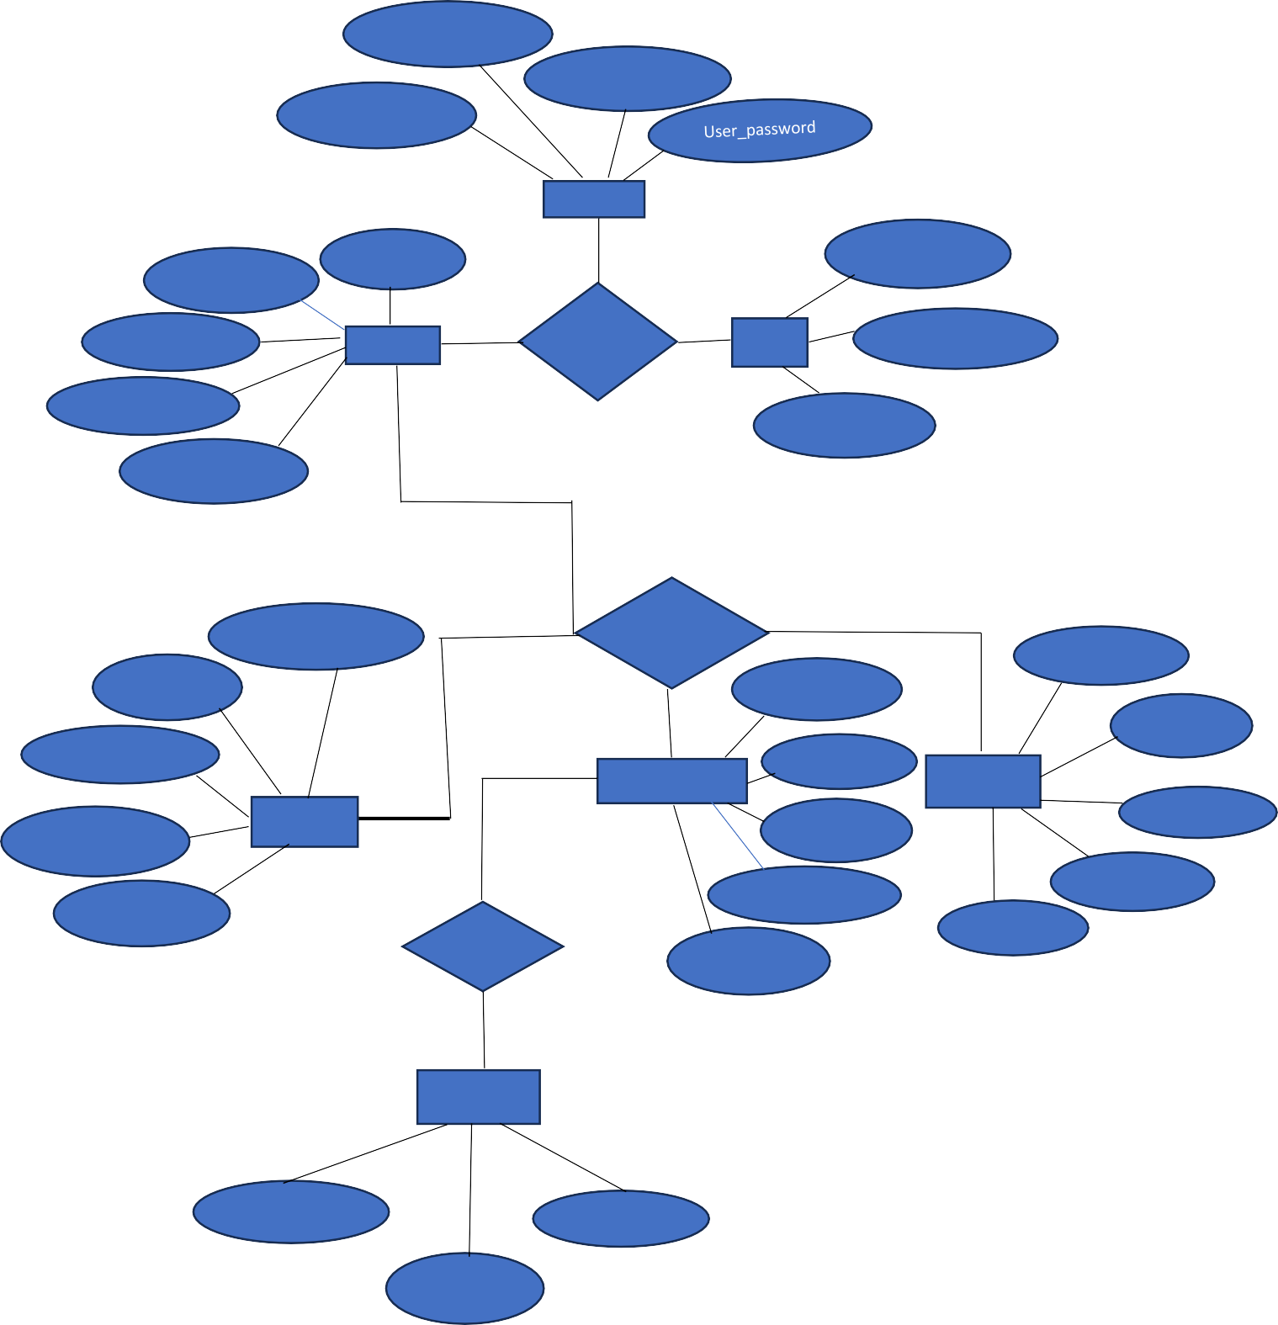

**F**g**i**y**g**m**u**_t**r**y**e**pe **: -**

# Figure :- Entity Relationship Diagram

**5 Implementation**

### 5.1 Form Layouts

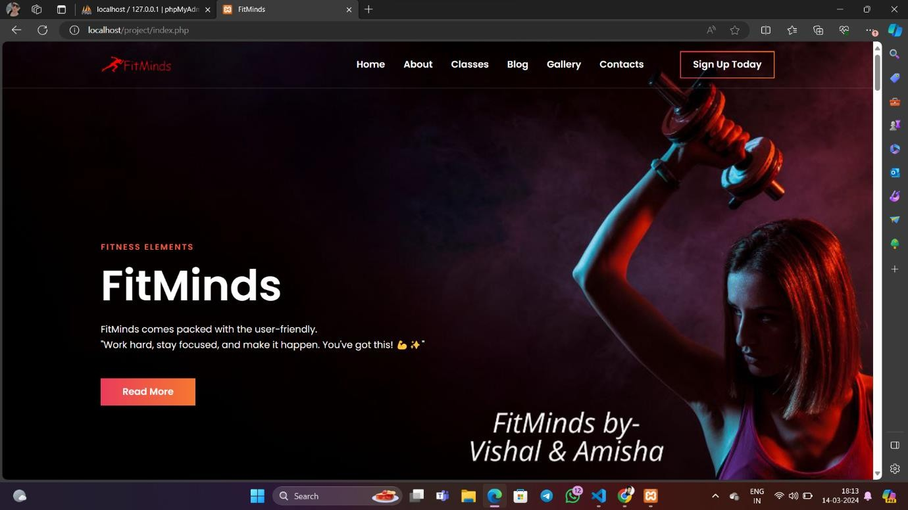

**Fig:- First page of our project.**

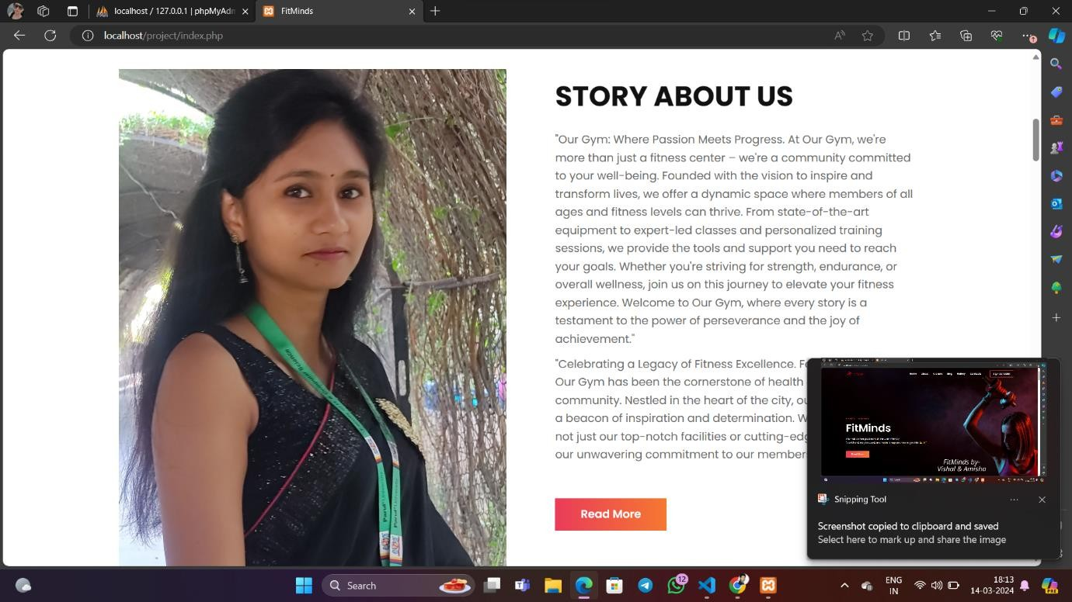

### Fig: - Second page of our project.



**Fig: - Third page of our project.**

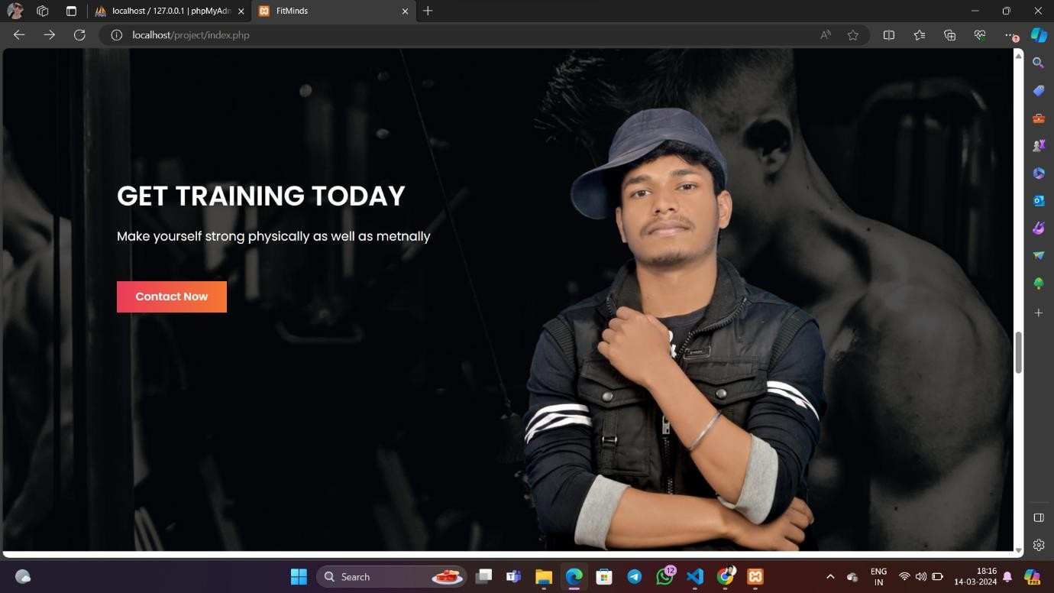

### Fig: - Fourth page of our project

**.2 Report Layouts**

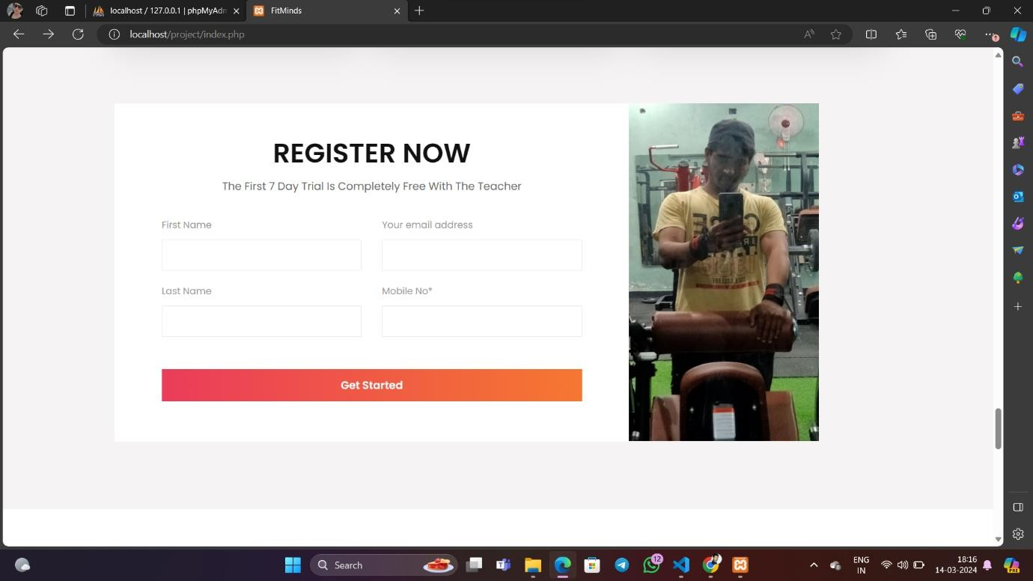

### Fig: - Register page

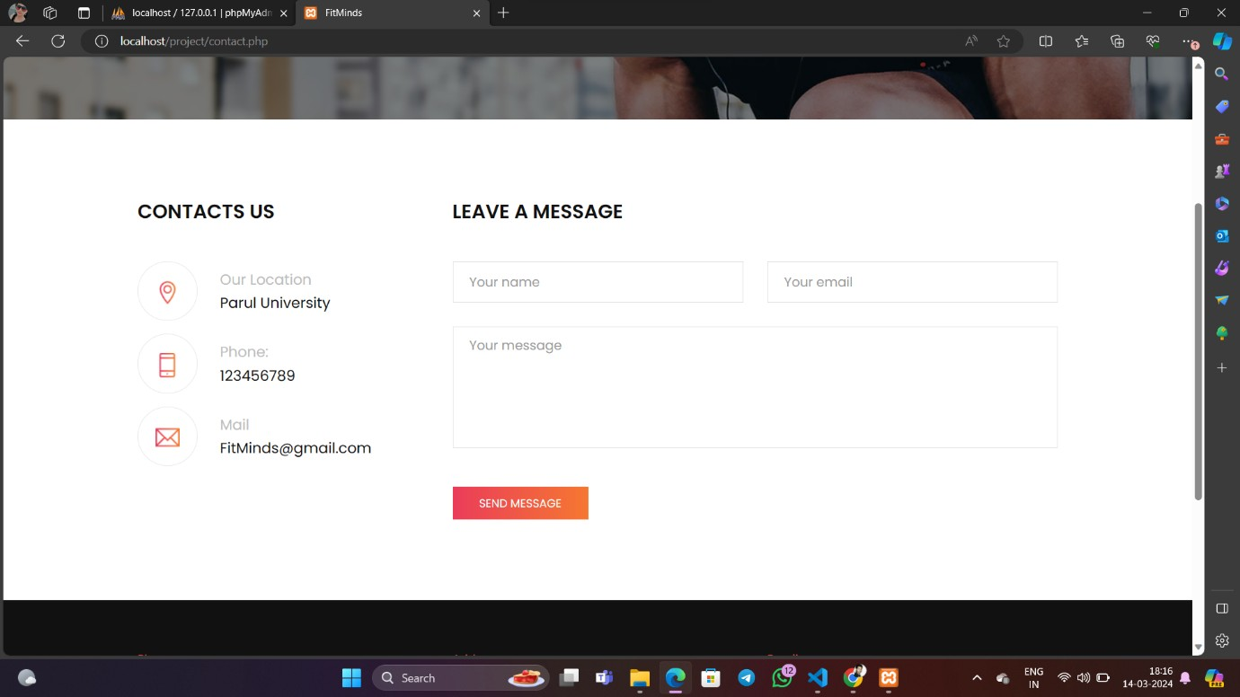

Fig: - Contact page of our project

**5.3 Coding Convention (Business Logic)**



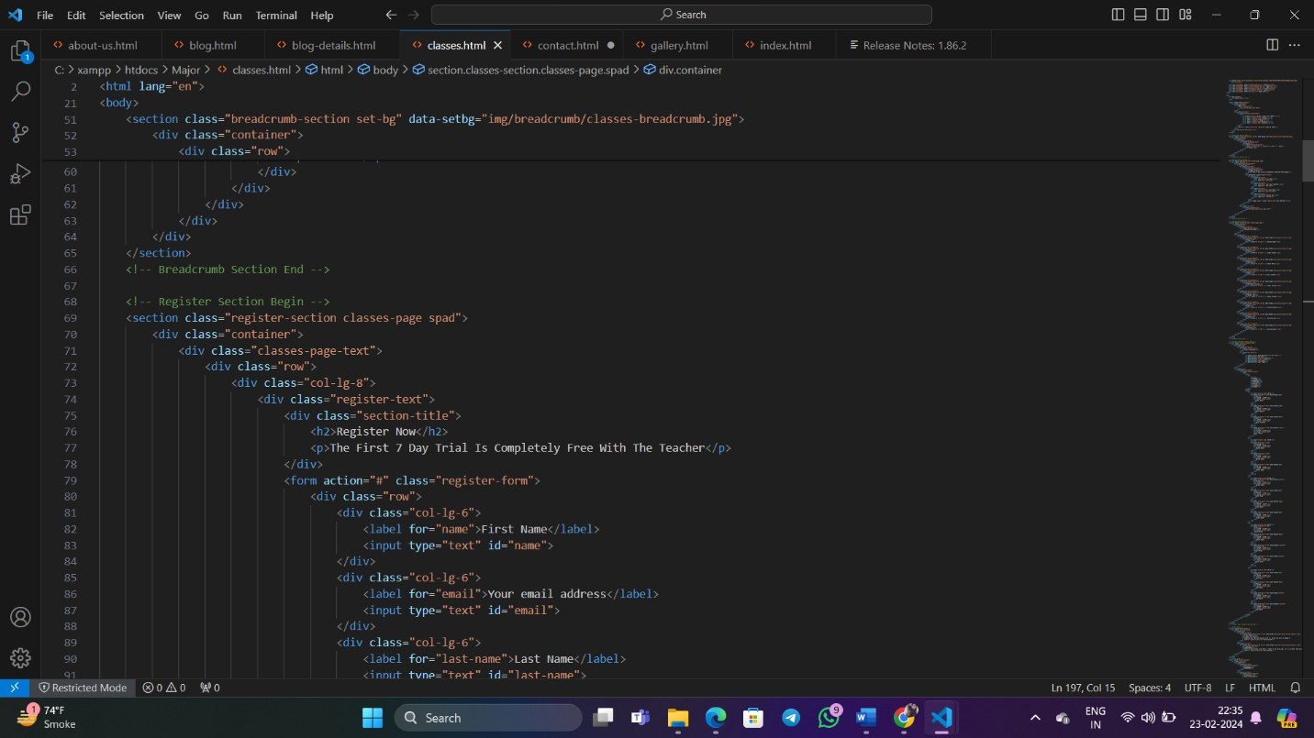

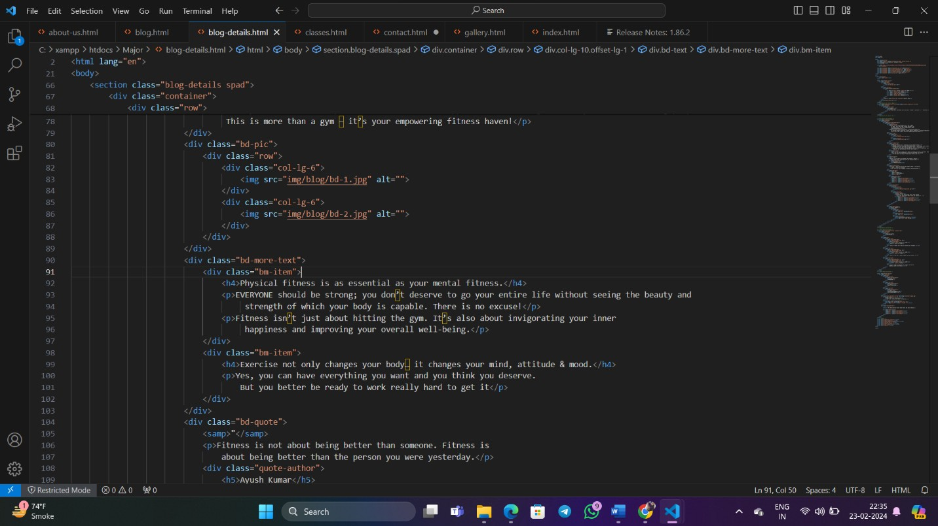



**Message**



Fig:- Message Sent Successfully

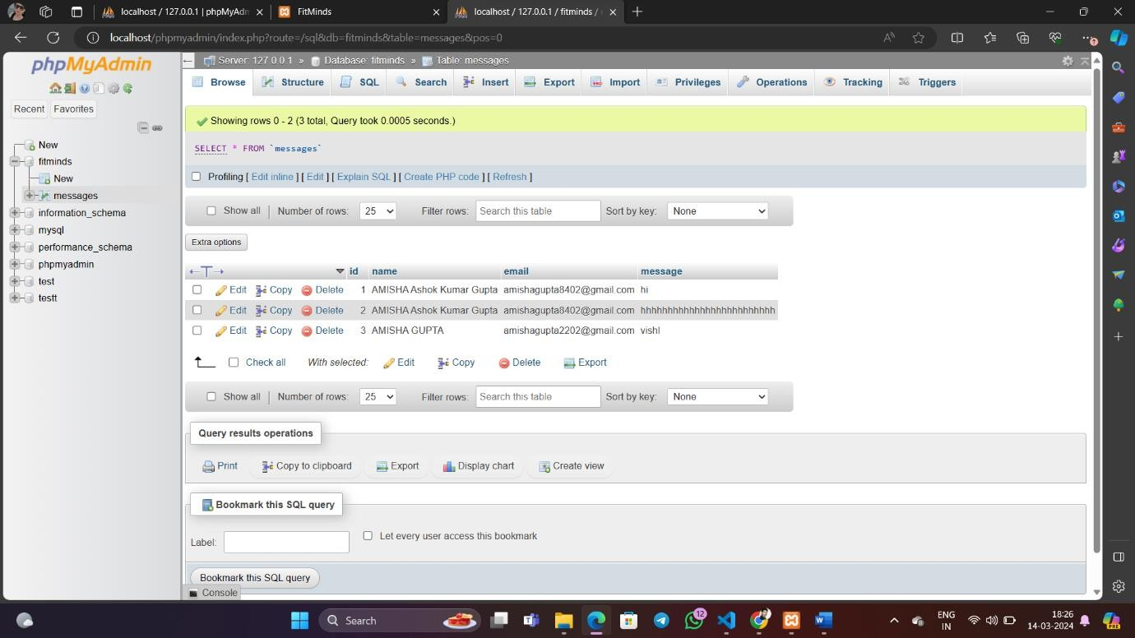

# Future Enhancement

Enhancing a gym website can significantly improve user experience, attract more members, and streamline gym operations. Here are some future enhancement ideas for a gym website:

Mobile App Development:

Develop a mobile app companion for the gym website, allowing members to access class schedules, book sessions, track workouts, and receive notifications on their smartphones.

Virtual Fitness Classes:

Introduce virtual fitness classes or on-demand workout videos accessible through the website, providing members with flexibility and convenience in their fitness routines.

Integration with Wearable Devices:

Integrate with popular wearable fitness devices such as Fitbit or Apple Watch, allowing members to sync their activity data with the website and track their progress seamlessly.

Online Personal Training Services:

Offer online personal training services through the website, enabling members to connect with trainers virtually for personalized workout plans, consultations, and progress tracking.

Nutrition Tracking and Meal Planning:

Implement nutrition tracking features and meal planning tools within the website, helping members achieve their fitness goals by monitoring their dietary intake and receiving personalized meal recommendations.

Social Community Platform:

Enhance the website with social networking features, enabling members to connect with each other, share workout tips, participate in challenges, and build a supportive fitness community.

Advanced Analytics and Reporting:

Expand analytics capabilities to provide detailed insights into member engagement, class attendance, revenue trends, and other key performance indicators, empowering gym owners to make data-driven decisions.

Online Merchandise Store:

Create an online store within the website where members can purchase gym merchandise, supplements, and fitness equipment, generating additional revenue streams for the gym.

Virtual Reality (VR) Fitness Experiences:

Explore the integration of virtual reality technology to offer immersive fitness experiences, such as virtual cycling tours or interactive workout games, enhancing member engagement and enjoyment.

Live Streaming Classes:

Introduce live streaming capabilities for fitness classes, allowing members to participate remotely in real-time classes from the comfort of their homes or while traveling.

Enhanced Booking and Scheduling System:

Improve the booking and scheduling system with features such as waitlists, recurring bookings, and advanced search filters, making it easier for members to find and register for classes.

By incorporating these future enhancements, a gym website can stay competitive, adapt to evolving member needs, and provide a modern and engaging fitness experience.

32

Gym Management System

33

Bibliography **2023-2024**

# Bibliography

Smith, John. "The Importance of Fitness Websites for Gym Businesses." Fitness Business Blog, 2020. [Online]. Available: https:/[/w](http://www.fitnessbusinessblog.com/importance-fitness-websites-gym-businesses/)w[w.fitnessbusinessblog.com/importance-fitness-websites-gym-businesses/.](http://www.fitnessbusinessblog.com/importance-fitness-websites-gym-businesses/) Accessed on January 15, 2024.

Johnson, Emily. "10 Essential Features Every Gym Website Should Have." Gym Owner Monthly, vol. 5, no. 2, pp. 15-20, 2021.

Fitness Industry Association. "Gym Membership Statistics Report." Fitness Industry Association, 2023.

Robinson, Mark. "The Impact of Mobile Apps on Gym Membership Retention." Journal of Fitness Technology, vol. 8, no. 4, pp. 321-335, 2019.

Davis, Sarah. "Designing a User-Friendly Gym Website: Best Practices and Tips." Web Design Magazine, vol. 12, no. 3, pp. 45-52, 2022.

Garcia, Maria. "Trends in Gym Website Development." Fitness Technology Conference Proceedings, 2023.

American College of Sports Medicine. "ACSM Guidelines for Exercise Testing and Prescription." 10th ed., Wolters Kluwer Health, 2020.

American Council on Exercise. "ACE Personal Trainer Manual." 5th ed., American Council on Exercise, 2019. Nielsen, Jakob. "Usability Engineering." Academic Press, 1993.

World Health Organization. "Physical Activity and Health." [Online]. Available: https:/[/w](http://www.who.int/news-)w[w.who.int/news-](http://www.who.int/news-) room/fact-sheets/detail/physical-activity. Accessed on January 15, 2024.

## Gym Management System